QR Code Generator Web Application

1.Title of the Document:
Using Web Technologies to Design and Develop a QR Code Generator

2.Project Aim:

To create a simple, lightweight online application that lets users create QR codes from text or URLs, with the ability to alter size, reset data, and save the result as an image.

3.Introduction:

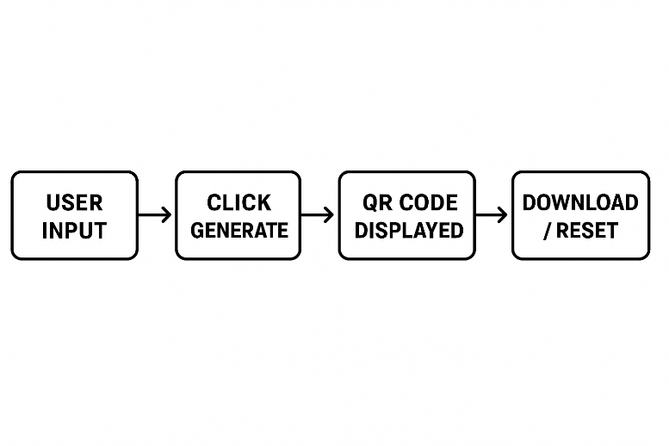
Quick Response (QR) codes are matrix-style barcodes that are often used for scanning-based data storage and sharing. They are utilized in event passes, Wi-Fi access, payments, and authentication.
The goal of this project is to combine HTML, CSS, and JavaScript, together with a small external library, to create a working QR code generator. With the help of the program, users may input a string (such as a URL), choose the size of the QR code, and have it appear instantaneously in the browser. Resetting the UI and downloading the created QR image are two more functions.

4.System Overview Diagram:
FLOW CHART:

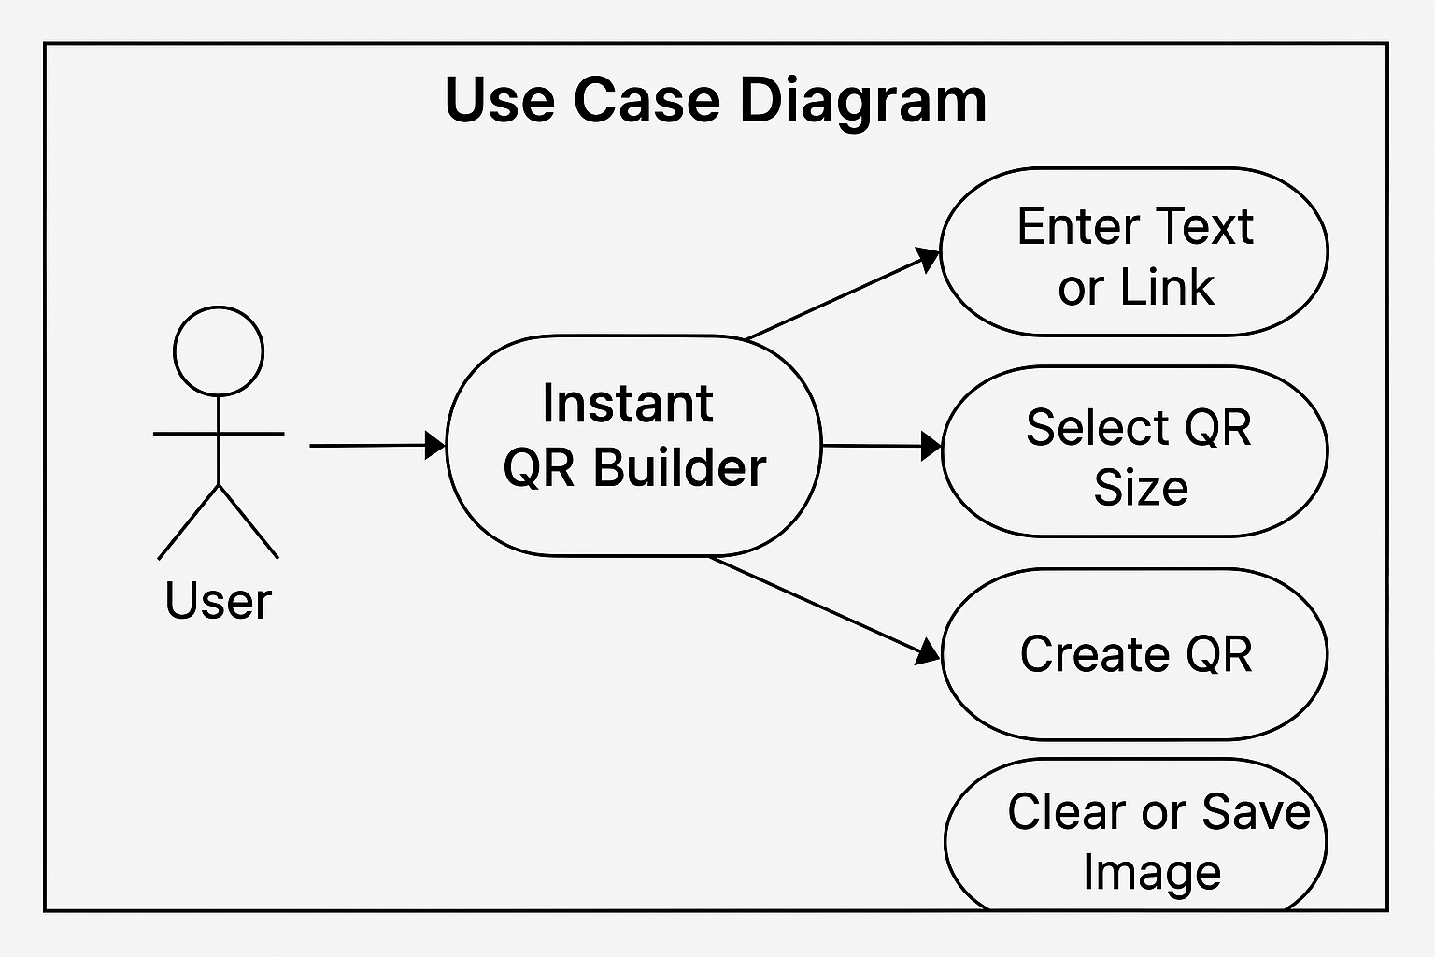

Here’s the use case diagram for your Instant QR Builder interface, showing how users interact with key features like creating, clearing, and saving QR codes.

5. Technical Steps
5.1. Project Files
- Index.html: This file contains the web page's components and structure.
- Style.css: Offers the application's visual style.
- main.js :The functionality for creating, deleting, and storing QR codes is handled by main.js.
5.2. HTML Structure
- The main page includes:
  - An input field for entering text or a link.
  - A dropdown menu to choose the QR code size.
  - Buttons for generating, clearing, and saving the QR code.
  - A portion where the produced QR code is shown.
  - Use script tags to load the main JavaScript file and the QR code library.

5.3. CSS Styling
- The CSS file ensures the application is visually appealing and easy to use.
- The layout is responsive, and elements are spaced for clarity.
5.4. JavaScript Functionality
- The JavaScript file manages:
  - Reading user input and selected size.
  - Creating the QR code using the QRCode class.
  - putting the QR code into the results section.
  - Clearing the input and QR code.
  - Downloading the QR code as an image.
5.5. QR Code Generation
- The application uses the qrcodejs library, loaded from a CDN.
- A new QR code is created by passing the input data and size to the library.
5.6. Image Download and Reset
- The "Save Image" button lets users download the QR code as a PNG file.
- The "Clear" button resets the input and removes the QR code from view.
5.7. Screenshots
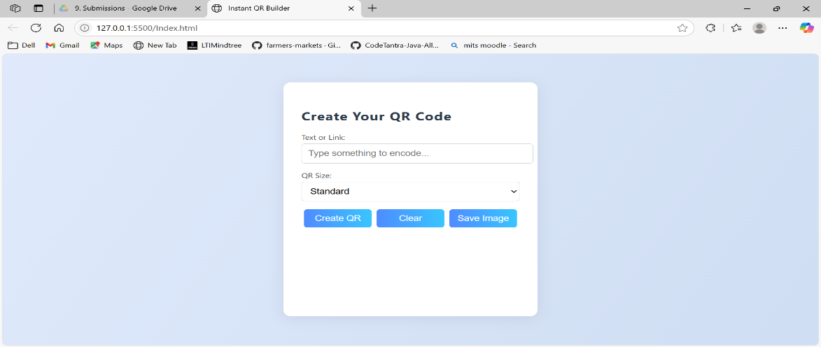

Fig:1 before QR Code generate.

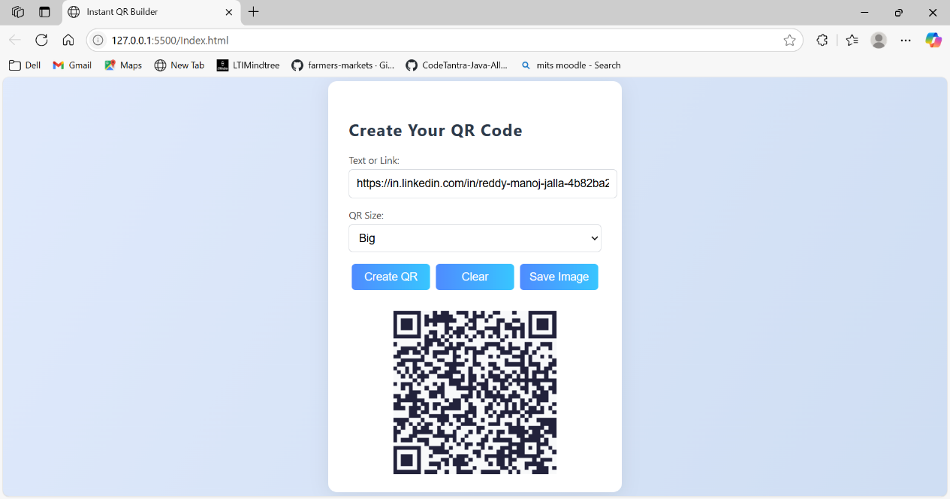
Fig:2 After QR Code Generation

6. Challenges and Limitations
- Customization: Only basic size options are available; advanced features like colour or logo insertion are not included.
- Input Checking: The app does not verify if the input is a valid URL or text.
- Mobile Experience: While the layout is responsive, further improvements could enhance usability on small screens.

7.Conclusion:
This project uses basic web technologies to provide an entirely client-side solution for creating QR codes in a web browser. It exhibits mastery of JavaScript, HTML, CSS, and external library integration. Despite having a simple look, it is expandable and can be improved with features like logo overlays, design themes, and QR personalization.

8.References:
1. QR Code Basics – https://www.qrcode.com
2. Front-End Web Docs – https://www.w3schools.com
3. Image Download in JS – https://developer.mozilla.org/en-US/docs/Web/API/HTMLAnchorElement/download

Codebase Structure
- index.html
- style.css
- script.js
- README.md
- GitHub: https://github.com/manoj7993/QR-code-Generator-App

